Neighbourhood Area Designation for Saddington Parish Neighbourhood Forum
As Saddington Parish Meeting is not an approved body to prepare a Neighbourhood Plan, the residents of Saddington parish and people who are employed in Saddington parish have formed a Neighbourhood Forum with the name ‘Saddington Parish Neighbourhood Forum’.
I am writing to inform you that Saddington Parish Neighbourhood Forum has taken the decision to develop a Neighbourhood Plan and the Forum is therefore applying to be designated as a Neighbourhood Area in accordance with Part 2 of the Neighbourhood Planning (General) Regulations 2012.
The area to be covered by the Neighbourhood plan is the whole of Saddington Parish. A map confirming the area to be designated is shown below with the boundary shown in red.
Saddington Parish Neighbourhood Area
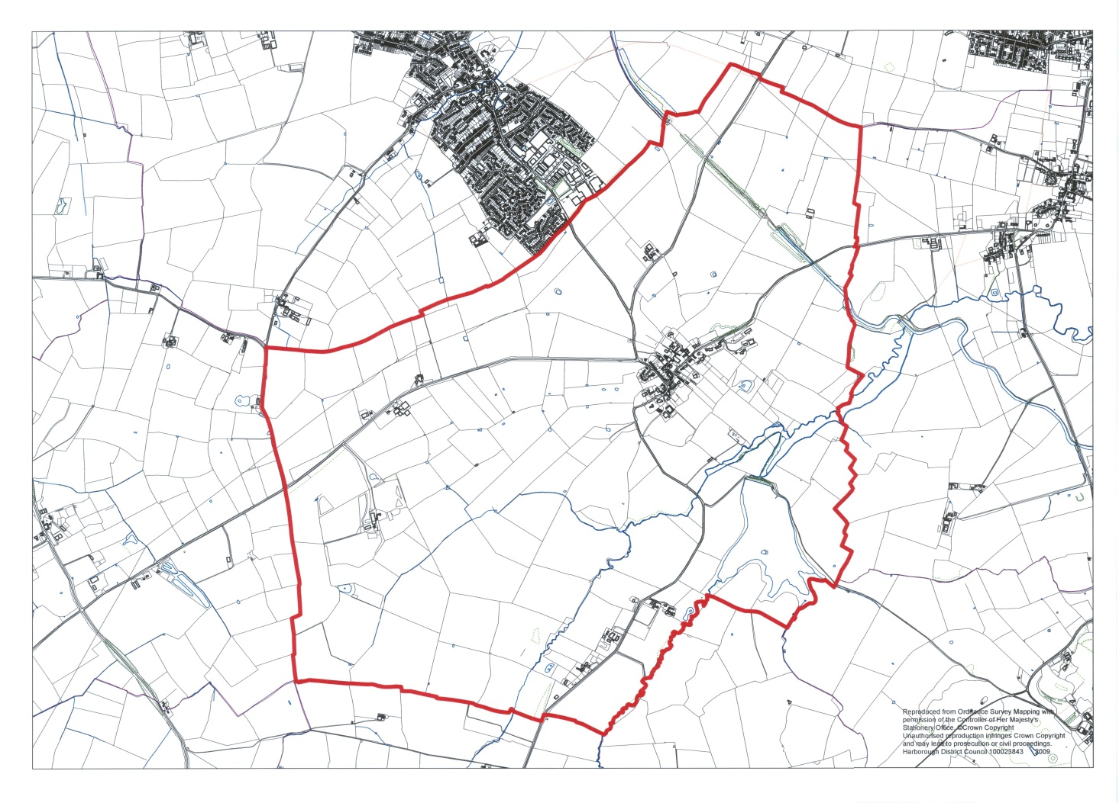
It is considered that the Neighbourhood Area detailed above is appropriate to be designated as it is the formal geographical boundary of Saddington which wholly contains Saddington village and associated working farms, Saddington reservoir and Saddington tunnel. The residents of Saddington village and people who are employed within Saddington parish value the identity and sense of community within the parish boundary and therefore wish to develop a Neighbourhood Plan for the future development of Saddington Parish.
Chris Carter
Chairman, Saddington Parish Meeting
On behalf of Saddington Neighbourhood Forum

